The Genesis Center 2nd Annual Car Show Benefit

First Name_________________________________________ Last Name_______________________________________________
Email ______________________________________________________________________________________________________
Home City__________________________________________________________________________________________________
Contact Phone #_____________________________________________________________________________________________
Vehicle Year________________________________________ Color___________________________________________________
Make______________________________________________ Model__________________________________________________
Noteworthy Facts About the Vehicle_____________________________________________________________________________
___________________________________________________________________________________________________________
___________________________________________________________________________________________________________
Club Affiliation_______________________________________________________________________________________________
1st Vehicle Registration $25 vehicle $_____________
T-Shirt (Men’s) $25 (Circle – Medium Large XL 2XL 3XL) $_____________

Please note: In recognition of the community, and the law, no burn-outs or unruly driving! Kids and families are present. Unless special permission has been given, and due to safety for all, no vehicles should leave before the awards ceremony. Winners must be present. Please clean up your area before departing. And hey, please respect the decisions by the volunteer judges. The fun show for car people brought to you by car people for a worthy cause.

I release the volunteers, organizers, sponsors and City from any damages during my voluntary car show participation.
Signature______________________________________________________________ Date_________________________________
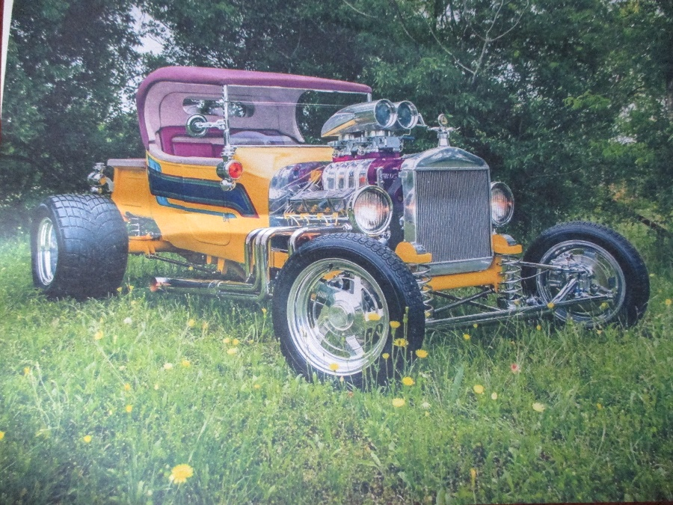
For more information, go to Classic Cruisers of Texas Facebook page

